
caMOD – Cancer Models Database

Software Design Description

Release 2.1 – Saving Queries

caMOD Team:

Srini Guruswami

David George

Ajay Gupta

Ulrike Wagner

Sima Pandya

Nicholas J Schroedl

Marc Piparo


Document Change Record
Version Number | Date | Description
1.0 | 03/08/06 | Initial document
1.1 | 4/05/06 | Revisions and screen shots
1.2 | 4/11/06 | After internal review, many changes throughout

TABLE OF CONTENTS
1. Introduction 1
1.1 PROJECT BACKGROUND 1
1.2 SYSTEM OVERVIEW 1
1.3 Requirements Traceability 2
1.3.1 Relevant Statement of Work Tasks 2
1.3.2 Functional and Technical Requirements 2
2. Use Cases 3
2.1.1 New Use Cases 3
3. Components 9
3.1 USER INTERFACE 9
3.1.1 Navigation Bar 10
3.1.2 Search Results Page – Save Query Fields 10
3.1.3 Manage Saved Queries 11
3.1.4 Search Page – Editing Saved Query 12
3.1.5 Search Results Page - Editing Saved Query 13
3.1.6 Search Results Page – Resubmit Saved Query 13
3.1.7 View Query History 14
3.1.8 Home Page 14
3.3 MIDDLE TIER 15
3.3.1 QueryStorageManager 15
3.4 BACK END 15
3.4.2 Domain Classes 16
3.4.3 Database Design 17

Introduction
The purpose of this document is to describe the design for saving user’s queries and search history for future editing and use. This is being developed for Release 2.1 of caMOD. This document identifies and defines the requirements for various user requests for the caMod application

Background/summary
The cancer models database (caMOD) is a web-based resource that provides information about rodent models for human cancer to the public research community.
caMOD provides the following key capabilities to its users:

- Data Submission--Data in caMOD are extracted from the public scientific literature by curators and verified by the scientists who generated or worked with the models, or they are directly submitted by scientists.

- Cancer Model Search--Users can retrieve information about the making of models, their genetic descriptions, histopathology, derived cell lines, associated images, carcinogenic interventions, microarray data, and therapeutic trials in which the models were used. caMOD provides links to PubMed for associated publications and other resources such as mouse repositories, detailed information about altered gene, pathway affected, and information about human clinical trials that utilize the same compounds as the pre-clinical trials in the animal models.

- System Function Administration--The Admin function provides services for user registration, review of submitted models and database management.

Requirements Traceability

Relevant Statement of Work Tasks
The caMOD Cancer Models Database Statement of Work (SOW) Task Description contains the following items that will be implemented as part of this design:
1. Develop a user preferences function that allows users to save and execute previously submitted queries. This involves:

a. Capture user’s queries and last execution date and time, and retrieve the queries at user’s request
b. Implement user preferences screens with the following functionality:
i. Recalling a user’s most recent query from previous site visits. The query can be saved and/or executed

Functional and Technical Requirements

The following is a more detailed list of requirements for this enhancement:
ID | Requirement
1 | Allow users to save an executed query
2 | Capture user's queries and last execution time
3 | Allow edit and delete of saved queries
4 | Retrieve 20 previously executed queries at user's request for re-execution
5 | Allow re-execution of queries

Use Cases
User preferences requirements were documented by a combination of adding new use cases and updating existing use cases.

New Use Cases

Save Query Use Case

Use Case Name | Save Query
Use Case ID | 1
Primary Actor | Researcher (User)
Trigger | User wants to save the query for future use.
Pre-conditions | User is logged in and has performed a search (simple, advanced or keyword) and is viewing the results of the search on the Search Results page. The search was conducted using a query that is not already saved.
Flow of Events | 1. User enters a name to call the saved query  2. User presses the “Save Query” button
Post-Conditions | Success Condition: The query is saved in the database for the user. User is returned to the Search Results page with a message indicating that the query has been saved successfully. The message includes the name of the query. The last executed time for the saved query is updated to the current date and time.  Error Condition: A query with that name already exists for this user. The user is returned to the Search Results page with error message displayed. The query is not saved. User then has the opportunity to enter a new name for the query.  Error Condition: User does not enter a name for the query and presses the “Save Query” button. The user is returned to the Search Results page with an error message indicating that the query name is required. The query is not saved. User then has the opportunity to enter a name for the query.
Alternative Flow

Manage Saved Queries Use Case

Use Case Name | Manage Saved Queries
Use Case ID | 2
Primary Actor | Researcher (User)
Trigger | - User clicks on the “View Saved Queries” link in the side navigation bar from any page in caMOD.  - User clicks the “Saved Queries” button while on the “Query History” page
Pre-conditions | User is logged in and has saved queries previously from simple/advanced/keyword search query page.
Flow of Events | - The user is presented with a list (sorted alphabetically by query name) of all of their saved queries. For each query, the following is displayed:  - Query name  - When the query was last executed (specifying timezone of EST)  - Button to resubmit the query  - Button to edit the query  - Button to delete the query  - User clicks on the query name to view details about the query’s criteria.  - User performs an action related to the saved queries (see related use cases).
Post-Conditions | List of saved queries is displayed.
Alternative Flow | If the user has not saved any queries, a message is displayed indicating that to the user in place of a list of saved queries.

Resubmit Saved Query Use Case

Use Case Name | Resubmit Saved Query
Use Case ID | 3
Primary Actor | Researcher (User)
Trigger | User wants to resubmit a saved query that has been previously run.
Pre-conditions | User is logged in and has saved one or more queries.
Flow of Events | 1. User navigates to the View Saved Queries page.  2. User presses the “Resubmit Query” button for the saved query that they want to run.
Post-Conditions | Success Condition: User is taken to the Search Results page with the results of the query displayed. The results are current as of the time when the query is run. The name of the saved query is displayed on the Search Results page. The last executed time for the saved query is updated to the current date and time.
Alternative Flow

Edit Saved Query Use Case

Use Case Name | Edit Saved Query
Use Case ID | 4
Primary Actor | Researcher (User)
Trigger | User wants to edit a query that was previously saved.
Pre-conditions | User is logged in and has saved one or more queries.
Flow of Events | 1. User navigates to the View Saved Queries page.  2. User presses the “Edit Query” button for the saved query that they want to edit.  3. User is taken to the Simple/Advanced/Keyword search page depending on what kind of query the saved query is. The saved criteria for the query are selected as criteria on the page.  4. User changes the criteria.  5. User presses the “Submit” button to run the query.  6. User checks the results and confirms that they want to save the query.  7. User selects that they want to update the query with the new criteria and presses the “Save Query” button.
Post-Conditions | Success Condition: Query is saved under the same name with new criteria. See use case 12.1.
Alternative Flow | 1. User chooses to save the query with a new name. User enters a name for the query and presses the “Save Query” button (see use case 12.1).  2. When the query is originally saved, it included criteria that are only available on the advanced search page. If that is the case, the user will be taken to the “Advanced Search” page instead of the “Simple Search” page when they press the “Edit Query” button.  3. User navigates off of the “Search Results” page to another page in the system. No changes are made to the saved query.

Delete Saved Queries Use Case

Use Case Name | Delete Saved Queries
Use Case ID | 5
Primary Actor | Researcher (User)
Trigger | User no longer needs some of their saved queries and wants to delete them.
Pre-conditions | User is logged in and has saved one or more queries.
Flow of Events | 1. User navigates to the View Saved Queries page.  2. User selects saved queries for deletion by clicking the trash icon.  3. User selects ‘Yes’ on the deletion confirmation message box.
Post-Conditions | Success Condition: The selected saved query is deleted from the database. User is taken back to the “View Saved Queries” page.
Alternative Flow

Resubmit Query from History Use Case

Use Case Name | Resubmit Query from History
Use Case ID | 6
Primary Actor | Researcher (User)
Trigger | - User clicks on the “View Query History” link in the side navigation bar from any page in caMOD.  - User clicks the “Query History” button while on the “Saved Queries” page
Pre-conditions | User is logged in and has previously performed one or more searches.
Flow of Events | - The user is presented with a list of the last 20 queries that they have run. The list includes queries that are saved queries as well as queries that are not. If a saved query has been run multiple times, it appears in the list multiple times. The list is sorted in descending order by Execution Date (most recent first).  - For each query, the following is displayed:  - “Execution Date” - when the query was last executed (specifying time zone of EST)  - “Query Name” – Either the name of the saved query or “No Name Provided”.  - “Resubmit” button  - User clicks on the query name to view details about the query’s criteria.  - User clicks the “Resubmit” button.
Post-Conditions | Success Condition: User is taken to the Search Results page with the results of the query displayed. The results are current as of that point in time. If the query is a saved query, the last executed time for the saved query is updated to the current date and time. Each query returned over the 20th query is deleted from the database.
Alternative Flow

Components

USER INTERFACE

Navigation Bar
Links will be provided in the left side navigation to give the user access to the View Saved Queries and View Query History pages. The link to view saved queries also displays number of queries that the user has saved (obtained using Constants.NUMBEROFSAVEDQUERIES). This number will update on login, save of new query or the deletion of a query. The links are accessible to all users and appear as follows:
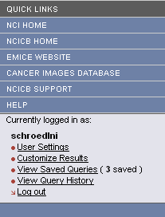

Search Results Page – Save Query Fields
The Search Results page will be changed to allow users to save the query that generated the displayed results. A text field to specify a name for saved query and a button to save the query will be added. When the button is pressed, the SaveQueryAction.do?method=save action is called.
The fields will look as follows:
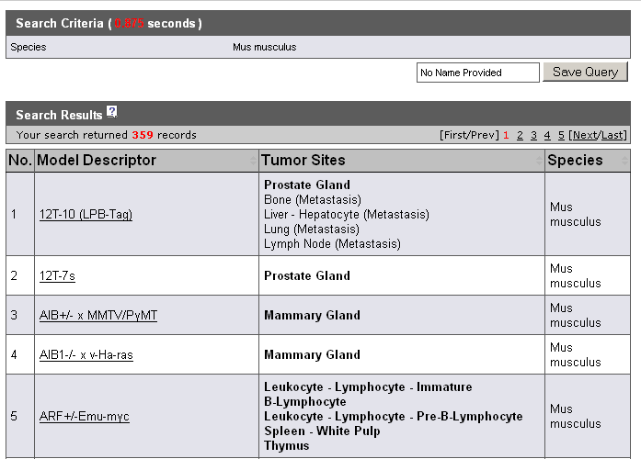
These new fields will not appear if a user is resubmitting a saved query.
When a user presses the Save Query button, the system attempts to save the query then returns the user back to the page. Based on the message provided, the user can determine success or failure and any additional actions that are required.
Message Type | Message
Information | Query ‘[Query Name]’ saved successfully.
Error | A saved query with that name already exists.
Error | Please enter a name for the query.

Manage Saved Queries
The Manage Saved Queries page is a new page that is accessed by clicking the “View Saved Queries” link in the side navigation bar. The page displays a table of all queries that are currently saved for the user and appears as follows:
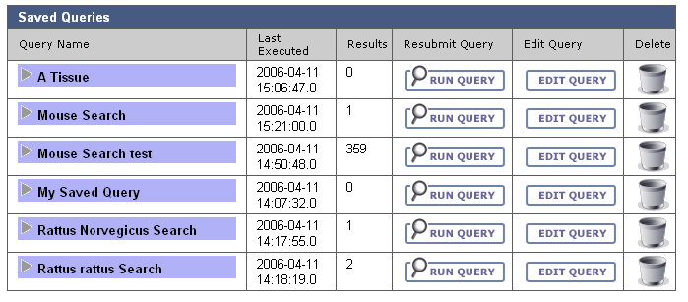
The table is sorted in descending order by Query Name. For each saved query, the table contains:
- The name of the query displayed as a link. The link toggles whether the criteria for the saved query are displayed. The default is that the criteria are not displayed. When shown, the criteria look as follows:
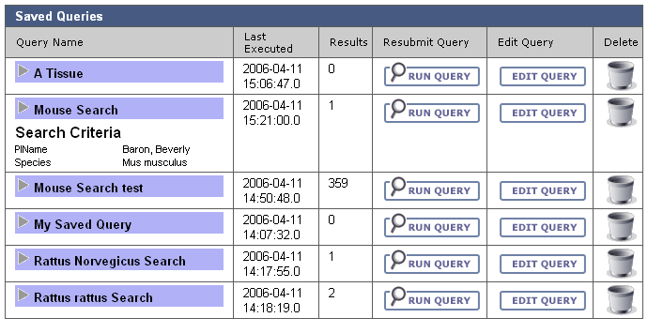
- The date and time of the last time the user executed the query in any way, obtained from the LastExecuted property.
- A button to resubmit the query that calls the SearchAdvancedAction.do action. Pressing this button submits the query using the saved criteria and displays results to the user on the Search Results page.
- A button to edit the query that calls the AdvancedSearchPopulateAction action. Pressing this button presents the user with the Search page displaying the criteria that was saved for the query. The user can then modify the criteria.
- A trashcan icon to delete the query.
Saved Queries page. Based on the message provided, the user can determine success or failure and any additional actions that are required.
Message Type | Message
Information | Saved queries were deleted.

Search Page – Editing Saved Query
The Search page allows a user to choose the criteria that will make up their query. To edit a query, the user is presented with the Search page prepopulated with the criteria stored for that saved query. To increase usability, the name of the saved query being edited will be shown in an information message that reads:
Saved query ‘[Name]’ is being edited. You will be prompted to save the changes after pressing Search.
The page will look like this:
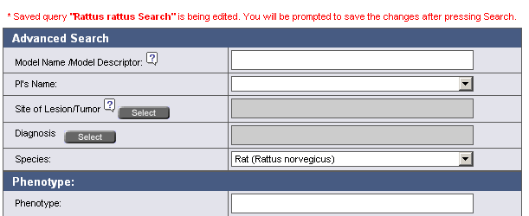

Search Results Page - Editing Saved Query
After a user has edited the criteria for a saved query, they are presented with the Search Results page showing the results returned for the edited criteria. At that point, users can choose to either update the query they are editing or create a new saved query with a different name.
To facilitate this choice, the ability to save or save as a new saved query will be added to the Search Results page and will only appear when users are editing a saved query.
The page will look like this:

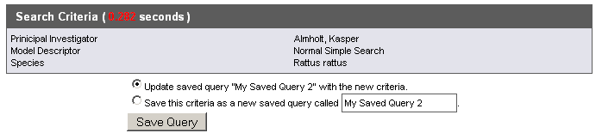
When a user presses the Save Query button.
Message Type | Message
Information | Query ‘[Query Name]’ saved successfully.
Information | Query ‘[Query Name]’ updated successfully.
Error | A saved query with that name already exists.
Error | Please enter a name for the query.

If the user does not like the results returned by the criteria, they can navigate back to the Search page to try again.

View Query History
The View Query History page is a new page that is accessed by clicking the “View Query History” link in the side navigation bar. The page displays a table of the last twenty (20) queries that the user executed. This includes any execution of a query, including both queries that are not saved and saved queries that are resubmitted. The page appears as follows:

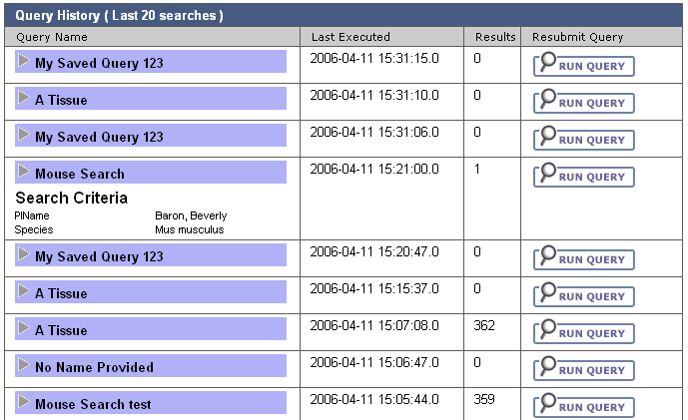
The table contains the following data for each query:
- The name of the query displayed as a link. The link toggles whether the criteria for the saved query are displayed. This is the same behavior that occurs when you click the name of a saved query on the Manage Saved Query page.
The text of the link can appear three different ways depending on the situation:
  - If the query was not saved, “No Name Provided” is displayed as a link.
  - If the query was a saved query and has not been edited since the last execution the name of the saved query is displayed.
- The date and time of the last time the user executed the query in any way.
- A button to resubmit the query. Pressing this button submits the query using the saved criteria and displays results to the user on the Search Results page.
The “Saved Queries” tab takes the user to the Manage Saved Queries page.

MIDDLE TIER

QueryStorageManager
QueryStorageManager is a new class that manages persistence for saved queries and query history records. Its methods will be:
Method Name | Description
save | - Creates a SavedQuery domain object.  Creates a SavedQueryAttribute domain object for each non-transient criteria and adds them as children of the SavedQuery domain object.
getSaved | Retrieves a list of all queries that isSaved is 1 (true) and are by supplied username
remove | Removes the savedQuery by id
getHistory | Retrieves all queries performed by a username that are not saved (isSaved is 0). Used to retrieve the query history
buildCriteriaList | Creates a list of SavedQueryAttributes from the SearchData. This list is saved as the search criteria for the SavedQuery.
update | Used to change values of isSaved. If isSaved is 1 then the query is a Saved Query for a user, otherwise it is a entry in the query history.
get | Retrieves a SavedQuery domain object by id

Domain Classes

SavedQuery
Attribute Name | Attribute Type | Description
id | Integer | Primary key (system generated)
user | many-to-one association to PARTY_ID | Reference to the user that saved the query
queryName | String | Name chosen for the query
SavedQueryAttributes | One-to-many association to SavedQueryAttribute | List of criteria that comprise the query
searchData | SearchData | Used to extract criteria for the SavedQueryAttributes.
executeTime | Date | Time when the query was last executed
elapsedTime | Long | Time query took to perform
isSaved | Long | Set to ‘0’ for a Query history item, set to ‘1’ for a user’s Saved query.
numberResults | Integer | Number of search results returned on last execution.

SavedQueryAttribute
Description: Child of SavedQuery. Represents the criteria for a SavedQuery record.
Attribute Name | Attribute Type | Description
id | Integer | Primary key (system generated)
attributeName | String | Fully qualified class name of the Criteria subclass that represents the criteria chosen by the user
attributeValue | String | Value chosen by the user for the criteria (e.g RIDER). Only one value will appear for each object. For example, if a user chooses to view data for multiple projects, there will be a SavedQueryAttribute for each project.
parentQuery | Many-to-one association to SavedQuery | Association to parent

Database Design

SAVED_QUERY
Table: SAVED_QUERY
Column Name | Column Type | Class / Attribute Name
SAVED_QUERY_ID | NUMBER | SavedQuery.Id
PARTY_ID | NUMBER | SavedQuery.User
QUERY_NAME | VARCHAR2(300) | SavedQuery.queryName
QUERY_EXECUTE_TIME | DATE | SavedQuery.executeTime
IS_SAVED | NUMER(1) | SavedQuery.isSaved
NUMBER_RESULTS | NUMBER | SavedQuery.numberResults

SAVED_QUERY_ATTRIBUTE
Table: SAVED_QUERY_ATTRIBUTE
Column Name | Column Type | Class / Attribute Name
SAVED_QUERY_ATTR_ID | NUMBER | SavedQueryAttribute.id
ATTRIBUTE_NAME | VARCHAR2(300) | SavedQueryAttribute.attributeName
ATTRIBUTE_VALUE | VARCHAR2(300) | SavedQueryAttribute.attributeValue
SAVED_QUERY _ID | NUMBER | SavedQueryAttribute.parentQuery

